GIDDY UP CUPE 101
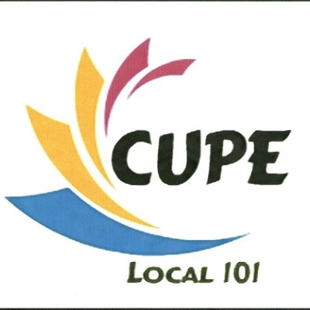

24TH ANNUAL LONDON PRIDE PARADE
Please join your fellow CUPE 101 brothers and sisters on Sunday, July 29th, 2018 @ 11:30 AM
We encourage all participants to come dressed in their best cowgirl/cowboy apparel.
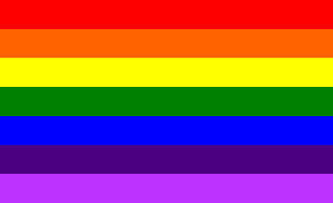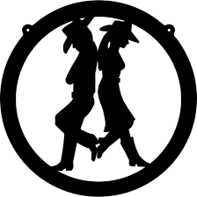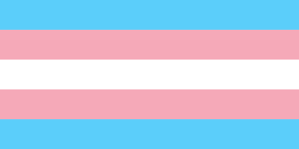

PARADE FORMATION
Formation for this year’s parade will take place around the Western Fair District Raceway. All participants are asked to meet at the corner of King Street & Ontario Street, where you will be given additional information about where to assemble your float/group. All personal vehicles will be asked to park at the Western Fair District Market at the corner of Dundas Street & Ontario Street. Any questions please do not hesitate to contact Ryan Campbell at ryancamp@london.ca

